Practical 8
Part A
1) | Guarded calculator: read two numbers and an operator; throw a custom  DivideByZeroException and catch invalid-number input separately, printing a clear  message each time; loop until a valid calculation succeeds and use finally to log each  attempt.
 | Calculator.java
Code | import java.util.Scanner;  class DivideByZeroException extends Exception {  DivideByZeroException() { super("Cannot divide by zero"); }  }  public class Calculator {  public static void main(String[] args) {  Scanner sc = new Scanner(System.in);  boolean done = false;  while (!done) {  try {  System.out.print("First number: ");  double a = Double.parseDouble(sc.nextLine());  System.out.print("Second number: ");  double b = Double.parseDouble(sc.nextLine());  System.out.print("Operator: ");  String op = sc.nextLine();  double result;  switch (op) {  case "+" -> result = a + b;  case "-" -> result = a - b;  case "*" -> result = a * b;  case "/" -> {  if (b == 0) { throw new DivideByZeroException(); }  result = a / b;  }  default -> throw new IllegalArgumentException("Invalid operator");  }  System.out.println("Result: " + result); done = true;  } catch (NumberFormatException e) { System.out.println("Invalid number"); }  catch (DivideByZeroException e) { System.out.println(e.getMessage()); }  catch (IllegalArgumentException e) { System.out.println(e.getMessage()); }  finally { System.out.println("Attempt logged"); }  }  }  }
Output | 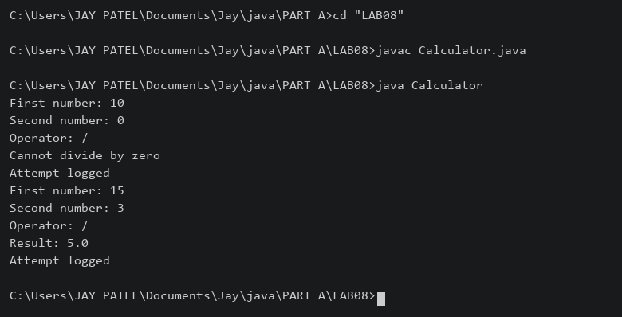

2) | Stock issue: a Warehouse where issue(item, qty) throws a custom checked  OutOfStockException carrying the shortfall, and InvalidQuantityException for qty ≤ 0.  Process a list of requests, catching and reporting each failure without stopping the run.
 | StockDemo.java
Code | import java.util.HashMap;  class OutOfStockException extends Exception {  private int shortfall;  OutOfStockException(int shortfall) {  super("Short by " + shortfall); this.shortfall = shortfall;  }  int getShortfall() { return shortfall; }  }  class InvalidQuantityException extends Exception {  InvalidQuantityException() { super("Quantity must be positive"); }  }  class Warehouse {  HashMap<String,Integer> stock = new HashMap<>();  Warehouse() { stock.put("Pen", 10); stock.put("Book", 5); }  void issue(String item, int qty)  throws OutOfStockException, InvalidQuantityException {  if (qty <= 0) { throw new InvalidQuantityException(); }  int available = stock.getOrDefault(item, 0);  if (qty > available) { throw new OutOfStockException(qty - available); }  stock.put(item, available - qty);  System.out.println("Issued " + qty + " " + item);  }  }  public class StockDemo {  public static void main(String[] args) {  Warehouse w = new Warehouse();  String[] items = {"Pen", "Book", "Pen", "Book"};  int[] qty = {4, 8, 0, 2};  for (int i = 0; i < items.length; i++) {  try { w.issue(items[i], qty[i]); }  catch (OutOfStockException e) { System.out.println(e.getMessage()); }  catch (InvalidQuantityException e) { System.out.println(e.getMessage()); }  }  }  }
Output | 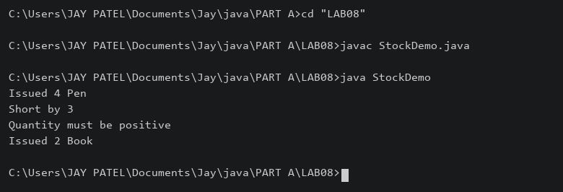

3) | (For Advanced Learners – home) Create an AutoCloseable resource and use try-with-  resources to prove it always closes — even when an exception is thrown inside the block  — and that the original error is the one reported. Decide what to model as the resource.
 | ResourceDemo.java
Code | class ReportSession implements AutoCloseable {  public void close() throws Exception {  System.out.println("Session closed");  throw new Exception("Close error");  }  }  public class ResourceDemo {  public static void main(String[] args) {  try (ReportSession session = new ReportSession()) {  System.out.println("Session opened");  throw new Exception("Original processing error");  } catch (Exception e) {  System.out.println("Reported: " + e.getMessage());  for (Throwable error : e.getSuppressed()) {  System.out.println("Suppressed: " + error.getMessage());  }  }  }  }
Output | 

